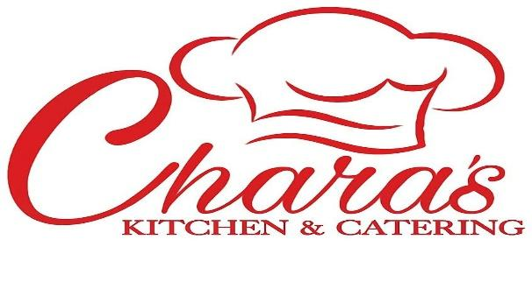
BBQ and Fish Fry Offerings

“Always Fresh and Made with Love…”

Pop-Up Spring to Winter 2019

Thursday to Saturday 2p to 9p

@Shiloh C.O.G.I.C 515 Atlantic Ave. Bellport, NY

(631)355-5929 Charascatering@gmail.com

Custom Menus Available Also! If it’s not here PLEASE ASK!
On-Site Catering available. Drop-off service available.

On site BBQ Services starting at $1375 for 50pp add'l $18pp over 50 (4hrs)
Includes:
Beef and Turkey Hamburgers/Cheeseburgers
Nathan's Hotdogs
Grilled Bbq Chicken
Macaroni Salad
Roasted Corn
Brown Sugar Baked Beans
Green Salad
Fresh Lemonade
All Condiments
Choice of Peach Cobbler or Signature Banana Pudding

On site Fish Fry Services Starting at $1950 for 50pp add'l $30pp over 50 (4hrs)
Pick 2:
Jumbo Shrimp
Fresh Whiting
Fresh Flounder
Fresh Catfish add'l $4pp
Snow Crablegs add'l $5pp
Lobster Tail add'l $12pp

Includes:
Roasted Corn
Fresh Coleslaw
Hush Puppies
French Fries
Green Salad
Sparkling Cherry Lemonade
All Condiments
Choice of Peach Cobbler or Signature Banana Pudding

*All menus are customizable.
*Additional hourly rate $100 per hour.
*Set up time not included in 4 hr. service

All Holiday orders require full payment to book services for said date, All Events require a 50% deposit to book with at least 2 weeks notice. Notification within less than 2 weeks of event requires full payment. Deposits can be made via PayPal charascatering@gmail.com or CashApp $CharasKitchen, GooglePay, Venmo or Zelle for your convenience. ALL CHECKS ARE TO BE WRITTEN TO: CHERYL GRIGG.
Balance due upon set-up or delivery. If there are any questions or changes, please feel free to call us. Thank you for considering Chara’s Kitchen and Catering.

